**Knight Moves**

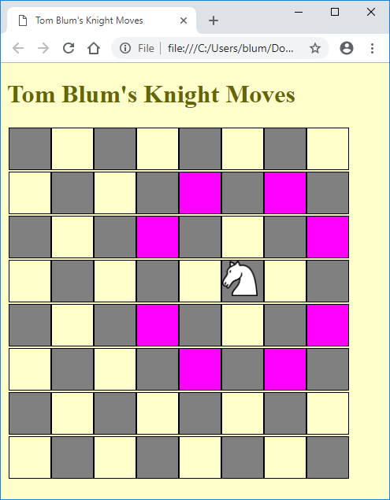 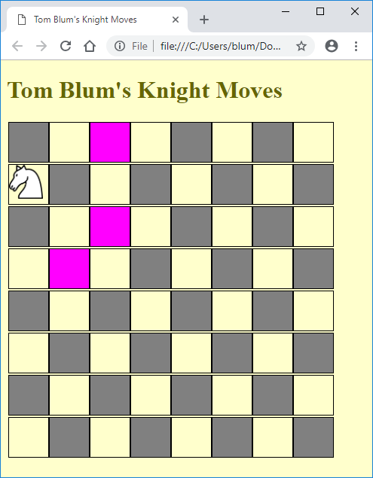

You will find in the head start **ChessBoard.htm** a webpage that places a white knight on a random square on a chess board – that is, it gives the class “hasKnight” to a random cell (table data item) of an eight-by-eight table.

1. Add a title John Smith’s Knight Moves (with John Smith replaced by your name).
2. Add an HTML comment with your name.
3. Make the page’s background color and (font) color anything other than the default values.
4. Put a header with John Smith’s Knight Moves (with John Smith replaced by your name) at the top of the page.
5. Place a JavaScript comment with your name at the top of the script area.
6. Adapt the code from either Table_f18.html or Minesweeper_f18.htm, so that when the **mouse** is **over** the cell with the Knight (i.e. one with “hasKnight” class), then highlight (give a background color to) the cells where the knight can move. A knight takes two steps in one direction and one step at a right angle to that. There are at most eight moves
   * Up two rows and one to the left
   * Up two rows and one to the right
   * Down two rows and one to the left
   * Down two rows and one to the right
   * Up one row and two to the left
   * Up one row and two to the right
   * Down one row and two to the left
   * Down one row and two to the right
7. You should have if’s to make sure that such a cell exits before trying to change its background color
8. When the user moves the **mouse out** of the cell any color you introduced should be removed.